**The Monty Hall Problem**

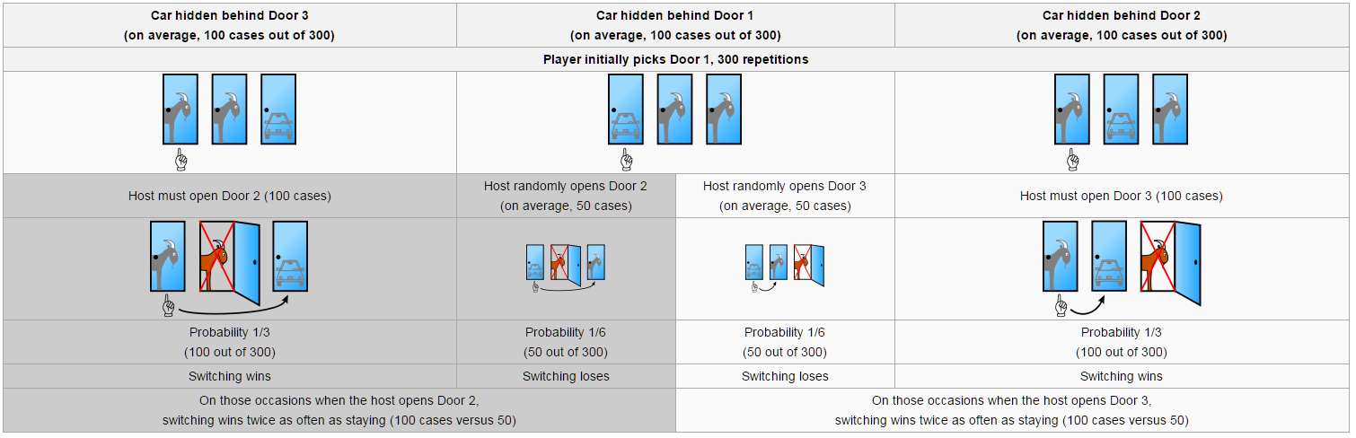

**This diagram helps to clarify the Monty Hall problem by showing how things would work in 300 hypothetical trials. The contestant has to decide to switch or not to switch based on additional information.**

**Since the car will be behind Door 1 one third of the time, if the contestant chooses to switch in this situation, he will lose as shown above. The question is then, why does switching have a probability of success of 2/3?**

**The goat (no car) will be behind door 1 two thirds of the time. In this case, once the contestant is shown another door does not have the car, if he chooses to switch and picks the third unopened door this guarantees a win.**

**Combining the different outcomes shows the decision to switch carries with it a probability of success of 2/3.**